**Device IoT Hub**

**Technical Design Document**

Client Token, Payment and Refund

Contents

1 Document Control 3

1.1 Change Record 3

1.2 Reviewer 3

1.3 Approver 3

2 Document Purpose 3

3 Design Diagram 4

4 Design Overview……………………………………………………………………………………………………………………………..4

4.1 Real Tme Data 4

4.2 Real Time Data Process Flow 5

4.3 Processed Data………………………………………………………………………………………………………………..5

4.4 Processed Data Process Flow……………………………………………………………………………………………6

4 Technical Details 6

4.1 Technical Language Specifications……………………………………………………………………………………..6

5 Error Handling 6

6 Assumptions 6

# Document Control

## Change Record

|  |  |  |  |
| --- | --- | --- | --- |
| **Date** | **Author** | **Version** | **Change reference** |
| 05/10/2021 | Prajeesh T S | 1.1 | Initial version |

## Reviewer

|  |  |  |
| --- | --- | --- |
| **Name** | **Role** | **Approval/Review Date** |
| Shobin Babu | Program Manager |  |

## Approver

|  |  |  |
| --- | --- | --- |
| **Name** | **Role** | **Approval/Review Date** |
|  |  |  |

# Document Purpose

This technical design document provides information about patient data collection and processing from medical devices.

* To facilitate real time patient data.
* To facilitate processed patient data.

# Design Diagram

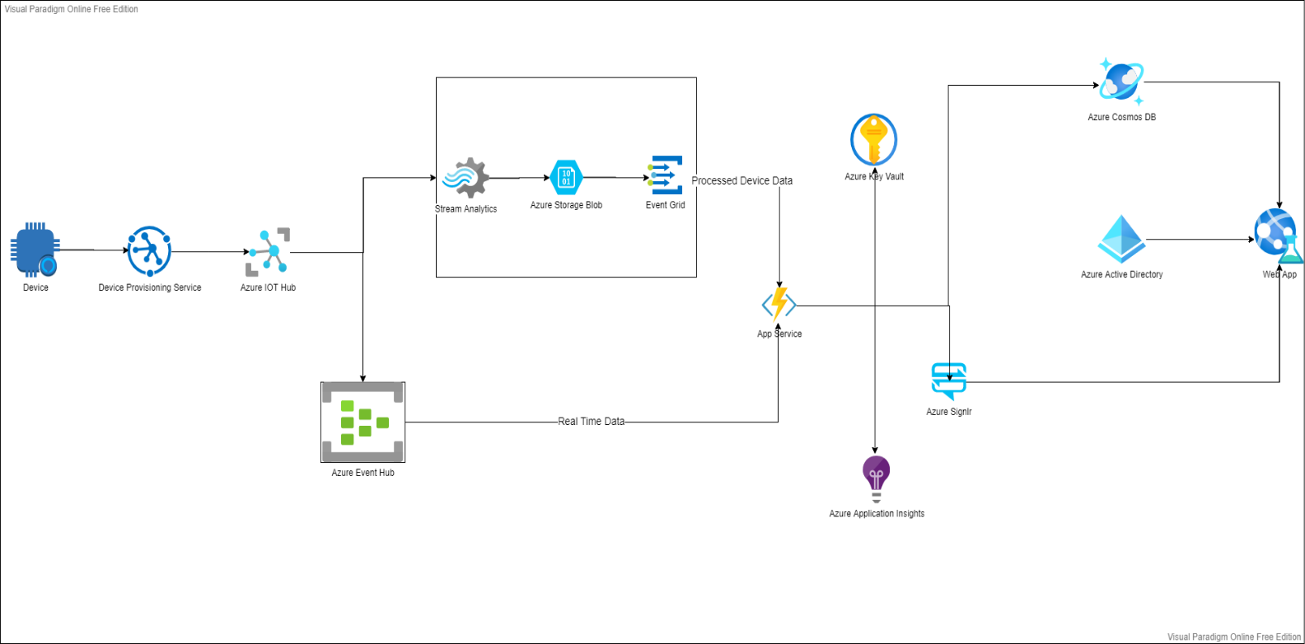

# Design Overview

## Real Time Data

The real time data process will be completed as per the below mentioned steps.

* The Azure active directory will be the first entry point.
* The service will compare the authentication parameters from user, once the authentication successful the below steps will be executed.
* The user will be navigated to the dash board of patients and the user can select single patient and device, upon selection the patient page will be displayed with real time data from that particular device.
* Logging will take place in accordance this application strategy
* Exception handling will take place in accordance to this application exception handling strategy

## Real Time Data Process Flow

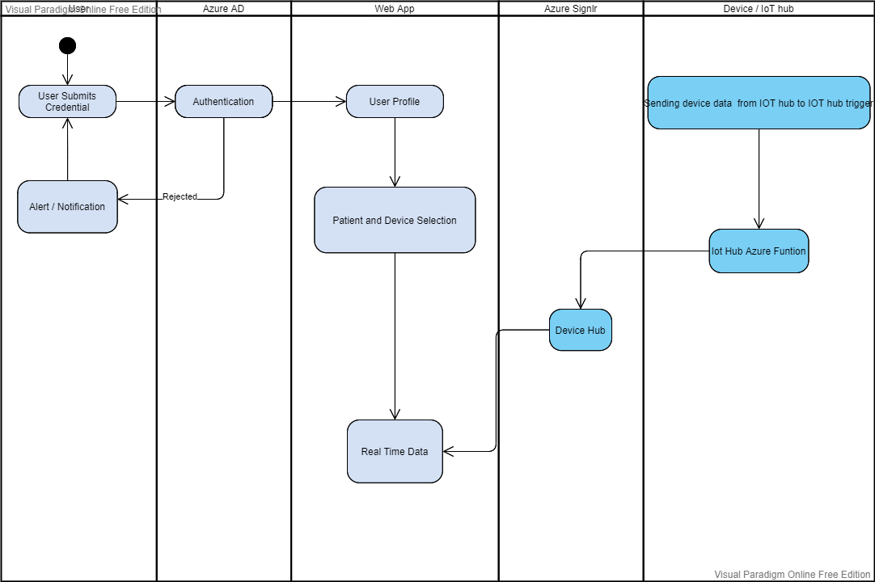

## Processed Data

The processed data process will be completed as per the below mentioned steps.

* The Azure active directory will be the first entry point.
* The service will compare the authentication parameters from user, once the authentication successful the below steps will be executed.
* The user will be navigated to the dash board of patients and the user can select single patient and device.
* The selected patient processed data will be collected from cosmos data base.
* Logging will take place in accordance this application strategy
* Exception handling will take place in accordance to this application exception handling strategy

## Processed Data Process Flow

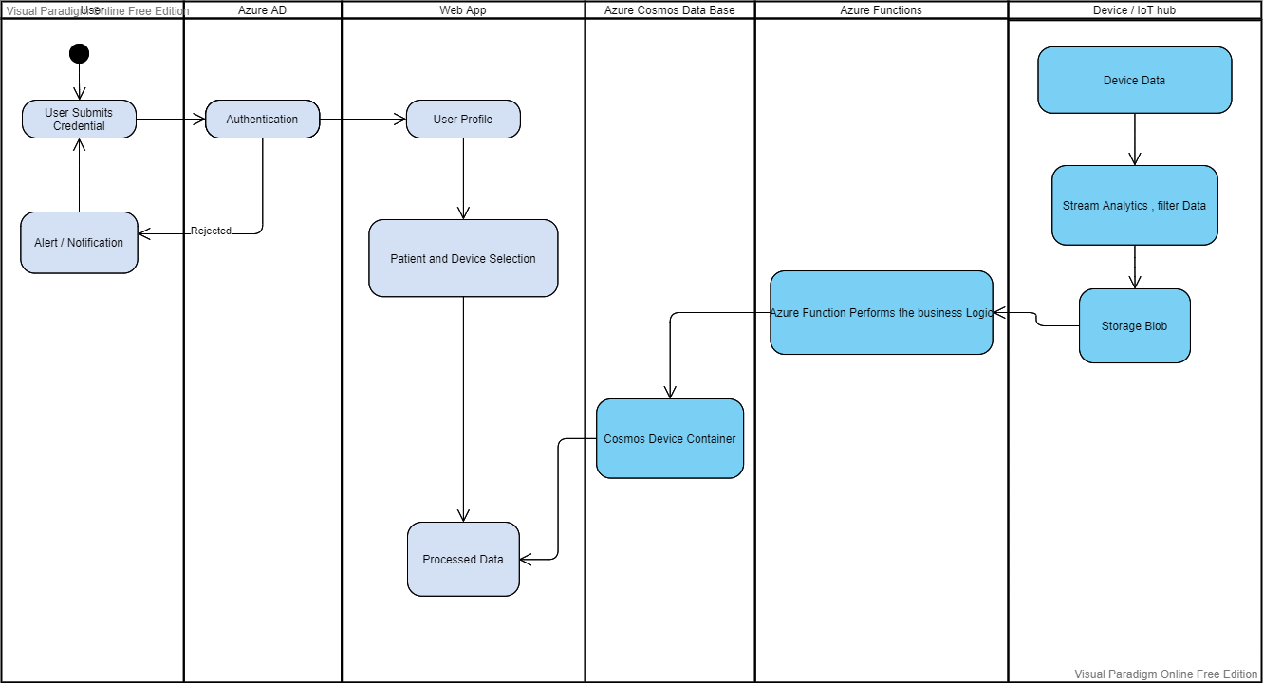

# Technical Details

## Technical Language Specifications

### Front End [ Web App]

Angular 11

Redux

### Back End [ Azure Functions]

.Net Core

### Cloud

Microsoft Azure

#### 

# Error Handling

1. In case of any errors in the system, the application insights can be drill down.

# Assumptions